Energy consumption and climate change: Insights from cooperative game theory

Daniel Piccoli and Ethan Norton

**Abstract:** Cooperative game theory solutions can demonstrate useful insights into how parties may use energy sources and share the benefits of cooperation. Here, a method based on Nash bargaining solutions is developed to explore energy consumption, in which energy companies have to negotiate their allowable energy levels with consumers. Based on the findings, a lack of incentive in cooperation will result in high summer month consumption levels in 2050. Further, effects of climate change on energy consumption are presented and explains how climate change may encourage cooperation among the parties to avoid higher costs in the future.

**Introduction:**

Energy companies are required to generate an amount of power that is equal to the amount consumed by their customers. One of the best ways to ensure an accurate volume of power generation is to increase the consistency or reliability of the behavior of customers. In 2019, residential energy accounted for 7 percent of the total energy consumption in America. Finding a way to normalize energy consumption in this demographic promises a nontrivial amount of stability to the total energy consumption nationwide. We propose a bargaining game between power companies, the government, and consumers, whose desires are to normalize consumption and continue as-is, respectively. During a literature review, we found a strong correlation between periods of extreme weather (winter and summer months) and an increase in power consumption. In order to equalize power consumption during these periods, we propose a weighted penalty system based on the statistical extremity of the temperature during a given month. Ultimately, we believe that imposing these sorts of penalties for overconsumption offers a possibility to normalize energy consumption across time.

It is crucial to environmentalists that excessive consumption is limited, otherwise it is likely that there will be irreversible ecosystem impacts before reduced consumption. Generally, environmentalists are expected to seek to reduce energy consumption overall, some other consumers are looking to have the same level as consumption, firms are looking to maximize profits, and the government is looking to maximize consumer energy consumption with energy production.

Game theory, the mathematical application of cooperation, may be used to interpret decision making and provide solutions to win-win scenarios. A similar study was done by(Madani 2011). The main goal of this paper is to apply cooperative game theory in order to understand the impacts of delaying energy consumption reduction. This study also elaborates on a cooperative game theoretic method based on a Nash bargaining solution for understanding optimal reduced consumption levels.

**Literature Review:**

The primary concern in writing this paper is addressing the risks of environmental damage due to excessive consumption of energy. The more energy is consumed, the greater the volume of fossil fuels that must be consumed, and therefore the more carbon emissions and heating of the planet occur. Moreover, this problem is exaggerated by the overconsumption of power - where there is an amount of renewable energy that can still be integrated into the energy plan, these risks are mitigated since the energy is generated cleanly. However, when more power is consumed than can be generated through renewable energy sources, the problem we describe occurs. One article finds an increase in energy consumption to be positively correlated with an increase in temperature, which poses the threat of a runaway model of energy consumption in the wake of global warming(Petrik 2010).

One study found that greenhouse gas emissions(GHG), especially carbon dioxide is one of the main causes of global warming(Soytas 2007). This paper also found that energy consumption causes CO2 emissions. There was also a link between GDP and energy consumption. Therefore, we can apply this to the model that increased consumption of energy in our models(displayed later) will lead to higher Co2 emissions, further increasing temperature in the future.

Another article found that there is growing consensus that emissions of greenhouses gases due to human activity will lead to higher temperatures and increased precipitation(Deschenes 2007). One paper explored that the governments have recently adopted some effective measures to fight against the energy crisis(Biligen 2014). Some overconsumption has already had some effects on the environment(acid rain and greenhouse gases). While clearly energy is essential for social development and quality of life, there has been excessive energy exploitation and pollution caused by fossil fuel consumption. In our cooperative game theory model, we account for the possibility of this occurring if the government does not take action in the near future.

**Models:**

**Figure 1: This figure contains an estimate of UK based Met Office data for 2018.**



**Source:** [**https://www.internetgeography.net/excel-climate-graph-template/**](https://www.internetgeography.net/excel-climate-graph-template/)

**Figure 2: This figure is one of the fundamentals of our analysis, and it explains the importance of regulating consumption(blue line), in order to avoid burning of fossil fuels.**

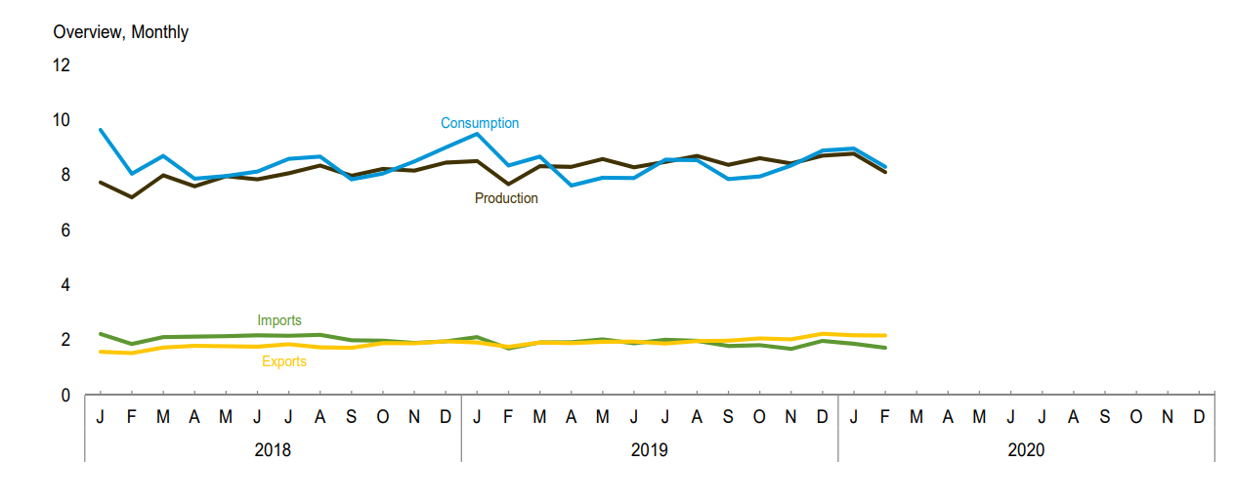

Source: <https://www.eia.gov/totalenergy/data/monthly/pdf/sec1_2.pdf>

The game is to keep energy consumption below energy production. Looking at Figure 1, we can see there are months where consumption exceeds production. We implement a bargaining game in hopes to at least reduce the gap between consumption and production in these months. The players are the Federal Government, Citizens, Energy Companies. For the preferences, Citizens prefer to use the same amount of energy, Energy Companies prefer to make money, Government prefers to match consumption and production. The rules and regulations are that the energy companies can’t store renewable energy and players must follow the law. If the government does not take action and mandate that energy companies weigh their prices as proposed here, then the 2050 model will reflect an increase in warmer months weights as a result of climate change.

The mathematical equation used to build Tables 1 and 2 are listed below. They are adapted from a paper that examines hydroelectric power generation(Madani 2011) . In that paper, there were penalties for changing the flow of the river, with an emphasis on months that were more crucial for the health of the fish that inhabit the river. Here, we have replaced fish health with extremity of weather, since that is strongly correlated with residential energy consumption. Months where weather deviates further from the annual average are weighted more heavily, since there is generally greater electricity consumption at those times.

2019 consumption:

( 2019 monthly weight) * abs( actual consumption - average available energy )^2

2050 consumption:

( 2050 monthly weight) * abs( actual consumption - average available energy )^2

**The 2019 weight was found by using the data found in figure 1 to find the standard deviation of each month from the average, average monthly temperature. We then found the standard deviation of each month, and divided each month’s standard deviation by the base highest month standard deviation(July) 2019. The result can be found in Table 1.

**The 2050 weight was found by using the data found in figure 1. We then added 1.5*C to each month, with 5.9*C to the warmest month as an estimate to address the impact of climate change if the 2019 model isn’t used([**https://www.bbc.com/news/newsbeat-48947573**](https://www.bbc.com/news/newsbeat-48947573)). We then found the standard deviation of each month from the average, average monthly temperature from 2019. Next, we calculated the standard deviation of each month, and divided each month’s standard deviation by the base highest month standard deviation(July 2019). The result can be found in Table 2.

**Table 1 - Monthly Energy Consumption Penalty weights in 2019(UK).**

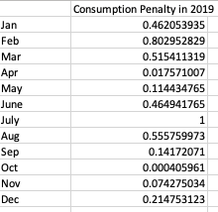

**Table 2 - New monthly energy consumption weights due to climate change in 2050(UK).**

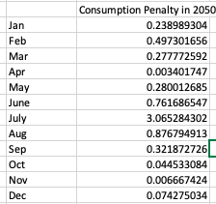

**Table 3: As we can see, the standard deviation of average weather temperature matches Figure 2.**

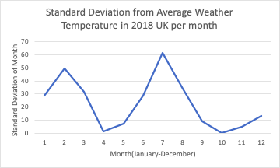

**Table 4: Now, we can observe that the standard deviation of average months has formed a more bell-shaped curve. This will be the impact of climate change, if the government does not intervene.**

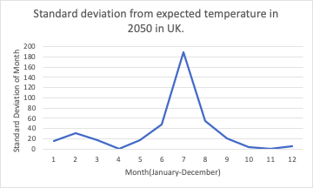

**Analysis of Models:**

The model we prescribe is a two-player bargaining game. The two players are energy companies and consumers. The energy companies have three potential strategies: maintain current energy costs, reduce energy costs, or apply further penalties for particular energy use habits. The consumers also have three strategies - they may choose to continue as-is, align their energy use with the energy companies’ desires, or further deviate from the desired patterns.

If energy companies and consumers make no changes to their behavior, the outcome is no net change. If consumers deviate further from the company’s goals, there will be only the normal increase in cost to them. If they work closer to plan, it will represent a reduced cost to them.

If energy companies reduce the cost of their service and do not implement sanctions and the consumer continues their normal use, it will occur at a reduced cost to the consumer, but with a reduced profit for the company. If the consumer decreases their use, it will represent an increased profit for the company, as they will more easily be able to meet the market demand for energy at a lower price. An increase in consumer use will result in more energy for less money on their end, but as the consumer continues to use energy at a rate greater than energy companies are naturally equipped to produce, it will cost the company more and more money to generate that power, reducing their profits.

If energy companies impose sanctions and customers continue their energy use as-is, it will increase company profit, but also fail to meet the goal of normalized energy consumption. If customers deviate from the plan, there will be a substantial profit, but this will be offset by the fact that the company is moving further away from its original goal. If the consumer aligns its behavior with the company goals, there will be no new profit, but the company will also have achieved its goal of normalized energy consumption. The supposed payoff table is below.

|  |  |  |  |
| --- | --- | --- | --- |
| **(u(Company),u(Consumer))** | **Deviate** | **Continue As-Is** | **Cooperate** |
| **Reduce Cost** | **(2,3)** | **(2,4)** | **(3,2)** |
| **Continue As-is** | **(2,4)** | **(3,3)** | **(5,2)** |
| **Impose Sanctions** | **(4,2)** | **(2,2)** | **(4,3)** |

These pairs are represented graphically below, with the disagreement pair in red and convex hull in black. Below the payoff graph are presented the Raiffa, Egalitarian, and Nash solutions.

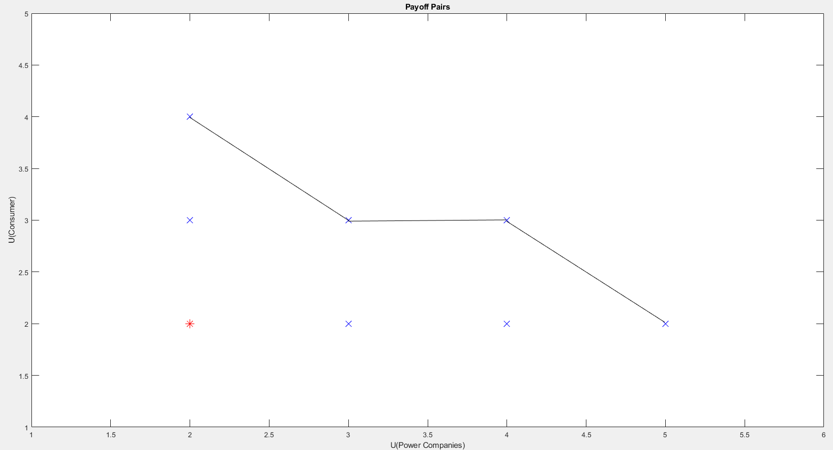

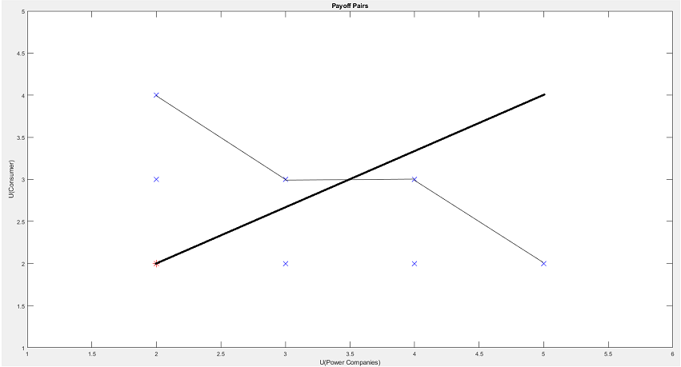

**The Raiffa payoff line, with intersection at (3.5,3)**

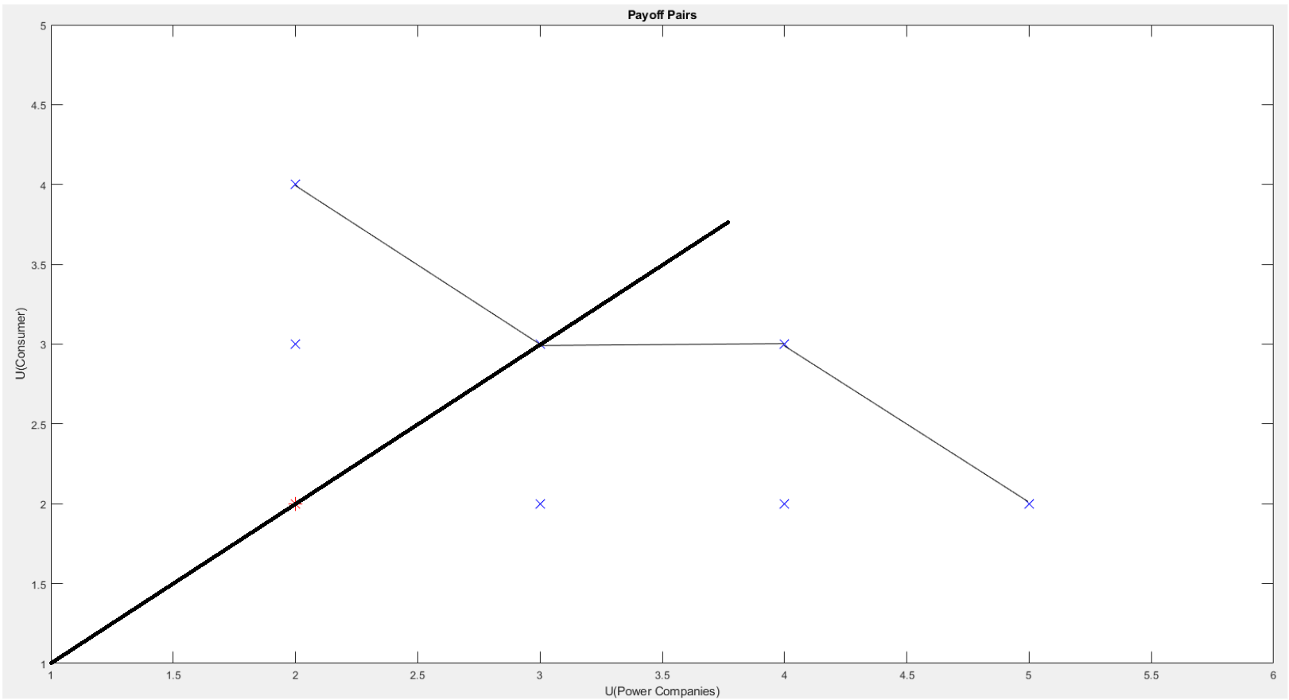

**The Egalitarian payoff line, with intersection at (3,3)**

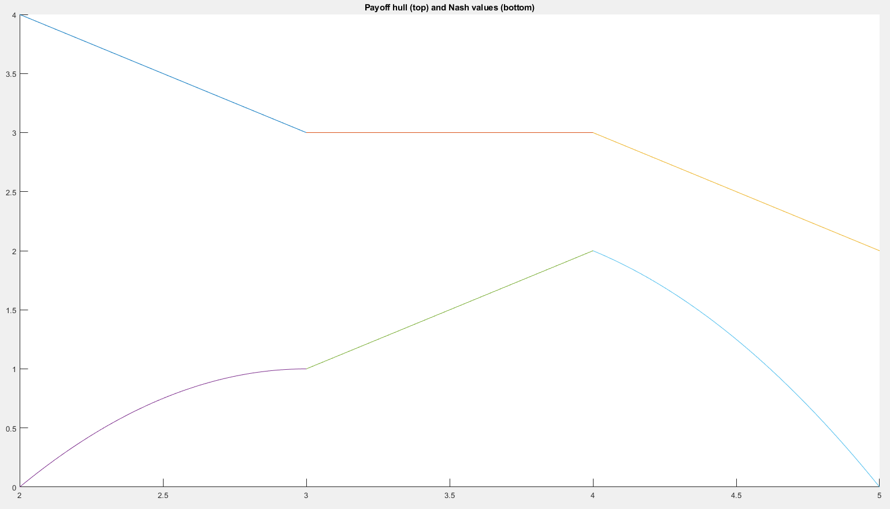

**Above, the payoff curve and the Nash payoff function (u1-d1)(u2-d2) below it.**

The Nash solution occurs at x=4, or the payoff pair (4,3), suggesting that the best strategy is for the company to impose sanctions and the consumer to comply. This is because, while the payoff for the consumer is consistent diagonally across the table, there is an incremental increase in the payoff to the utility company as its strategy deviates towards the imposition of sanctions. Given that there is no effect on the consumer, and the energy company continues to benefit as the strategy shifts, we propose an optimal solution of energy companies imposing sanctions with which the consumer complies.

**Conclusion:**

If the utility values assigned to the bargaining game can be considered viable, then the cooperative game analysis performed in the study can be quite applicable to future energy consumption dilemmas. It is difficult to say if this model is accurate, as the assigned utilities were educated guesses. The Raiffa, equilibrium, and Nash equilibrium solutions all yield similar equilibrium pairs: (3.5,3), (3,3), (4,3) respectively. The solutions all are in favor, or equal to the side of the energy company.

In the future, we hope that this model, or a similar model can be used to mitigate damage done to the ecosystem. If the government does not choose to intervene and target energy consumption, we can almost definitely expect there to be an increase in weather temperatures, and further perpetuate the amount of energy consumption by consumers.

**Bibliography:**

**Bilgen, S. “Structure and Environmental Impact of Global Energy Consumption.” *Renewable and Sustainable Energy Reviews*, vol. 38, 2014, pp. 890–902., doi:10.1016/j.rser.2014.07.004.**

**Deschenes, Olivier *The Economic Impacts of Climate Change: Evidence from ...* econ.ucsb.edu/~olivier/DG_AER_2007.pdf.**

**Madani, Kaveh. “Hydropower Licensing and Climate Change: Insights from Cooperative Game Theory.” *Advances in Water Resources*, vol. 34, no. 2, 2011, pp. 174–83. *Crossref*, doi:10.1016/j.advwatres.2010.10.003.**

**Petrick, Sebastian, et al. *The Impact of Temperature Changes on Residential Energy ...* 2010, internationalenergyworkshop.org/iew2009/speakersdocs/Petrick-et-al_TheImpactOfTemperatureChanges.pdf.**

**Soytas, Ugur, et al. “Energy Consumption, Income, and Carbon Emissions in the United States.” *Ecological Economics*, vol. 62, no. 3-4, 2007, pp. 482–489., doi:10.1016/j.ecolecon.2006.07.009.**

<https://www.eia.gov/totalenergy/data/monthly/pdf/sec9_11.pdf>

[**https://www.bbc.com/news/newsbeat-48947573**](https://www.bbc.com/news/newsbeat-48947573)

[**https://www.internetgeography.net/excel-climate-graph-template/**](https://www.internetgeography.net/excel-climate-graph-template/)